**Designing The UpdateEmployeesFrame**

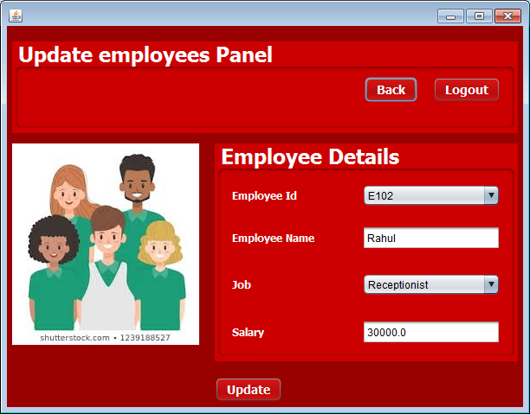

**STEPS TO BE DONE IN** **UpdateEmployeesFrame**

In the **UpdateEmployeesFrame** we need to do following steps:

1. Handle the constructor for proper initialization of class members

2.In the constructor we also have to load the Empids from the Database and display all the Empid in jComboBox.

3. Allow the user to **logout**

4. Write code for the "**Update**" Button . When this button is clicked it should:

1. **Validate the inputs. If validation fails it should print the Error Message and return**
2. **Create a new object of Employee POJO and initialize it with the details about the Employee.**
3. **When the “Update” button is clicked we have to update the existing employee in the database**
4. **Load and show the empid again**

7. Write code for the "**Back**" Button . When this button is clicked it should:

a**. Dispose the current frame and open the ManageemployeesFrame**

**THE TABLES USED IN UpdateEmployeesFrame**

**1.Employees**

|  |  |  |
| --- | --- | --- |
| **Column Name** | **Data Type** | **Description** |
| **EMPID** | **Varchar2(10)** | **Contains Userid** |
| **EMPNAME** | **Varchar2(10)** | **Contains password** |
| **JOB** | **Varchar2(10)** | **Contains job profile** |
| **SALARY** | **NUMBER(6,2)** | **Contains Salary** |

**THE POJO CLASSES USED IN UpdateEmployeesFrame**

1. The **Employee** POJO

**THE DAO CLASSES USED IN UpdateEmployeesFrame**

1. The **EmployeeDAO**

**HOW TO LOAD AND SHOW THE QUESTIONS:**

The first step we need to do in the **constructor** of **UpdateEmployeesFrame** is to load all the Empid from the database and show the first empid in jComboBox.

To do this we will create a method called **getAllEmpID( )** in the **EmployeesDAO**. The prototype of the method is:

***public static ArrayList<EmpPojo> getEmpIds()throws SQLException***

To call this method from **UpdateEmployeesFrame** we will create a method called **loadEmpIds( )** in the **UpdateEmployeesFrame**

**Handling the constructor:**

The constructor should do the following:

1. Display the username
2. Load all the Empids from the database and show the first empid.